MySQL Assignment 1
DDL Commands & Constraints

Name: HARITHA HARI
Batch: 69

DDL Commands:

- Table Creation (CREATE): Write the SQL statements to create a database named “employee” and the following tables based on the provided schema:

⦿ Departments

SQL Code for creating a new table named ‘departments’

create database employee;
use employee;
create table departments(
department_id int,
department_name varchar (100));

Output of the created table ‘departments’, use “select * from departments“
To show the output.
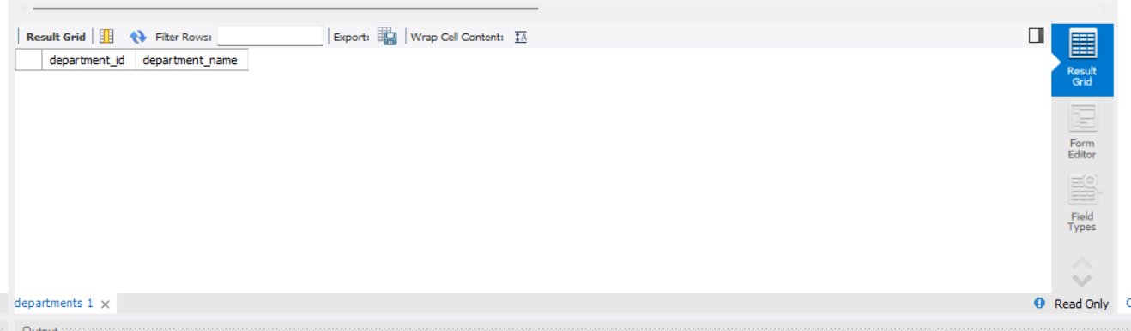

⦿ Location

Code :
Create table location (
location_id int ,
location varchar (30));

Output:

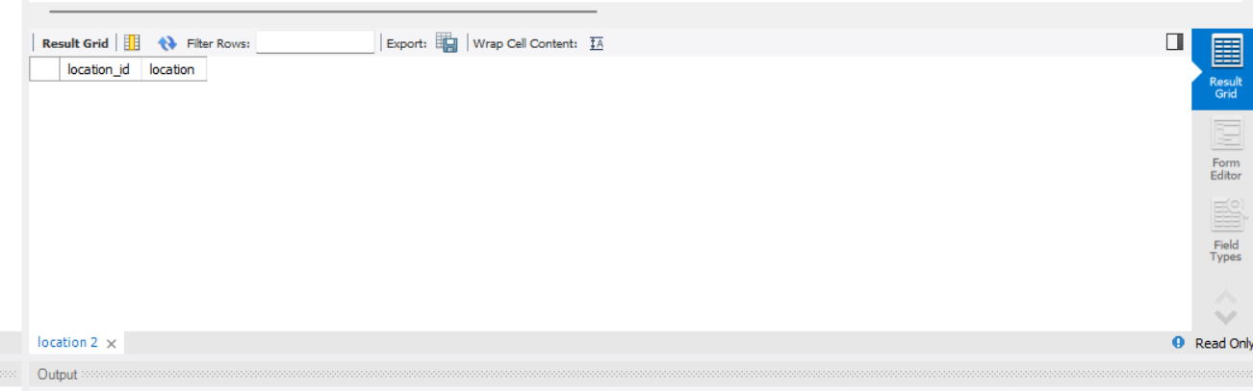
⦿ Employees

Code:

create table employees (
employee_id int ,
employee_name varchar (50),
gender enum ('M','F'),
age int ,
hire_date date ,
designation varchar (100),
department_id int ,
location_id int ,
salary decimal(10,2));

Output:

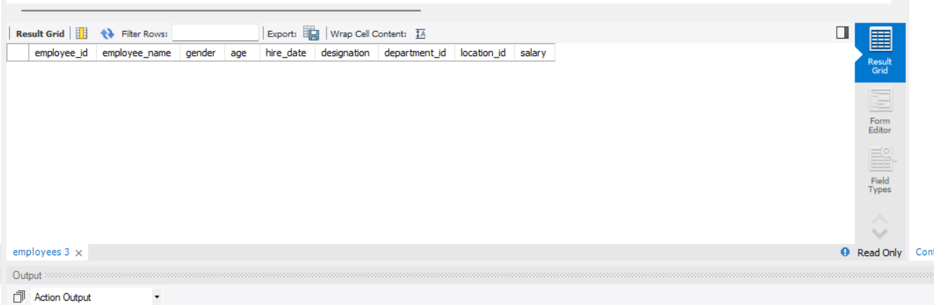

- Table Alteration (ALTER): Consider the following scenarios and write the SQL statements to alter the structure of the tables accordingly:

⦿ Add a new column named "email" to the Employees table to store
employee email addresses.

Code:

alter table employees
add email varchar (100);

Output:

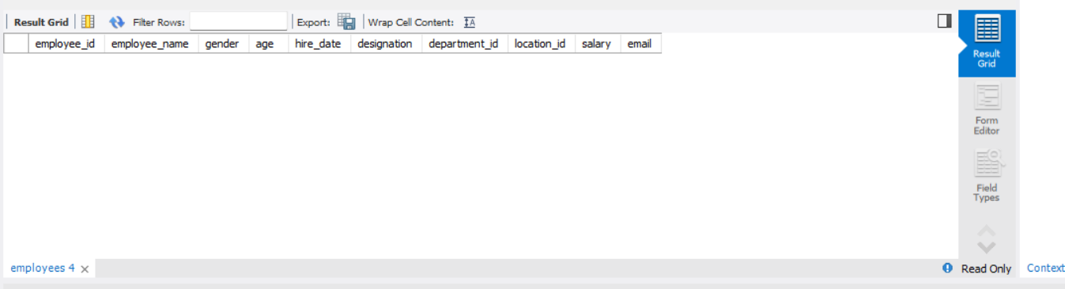

⦿ Modify the data type of the "designation" column in the Employees
table to support a wider range of values.

Code:

alter table employees
modify designation varchar (200);

Output:

⦿ Drop the “age” column from the Employees table.

Code:

-- drop --

alter table employees
drop column age;

Output:

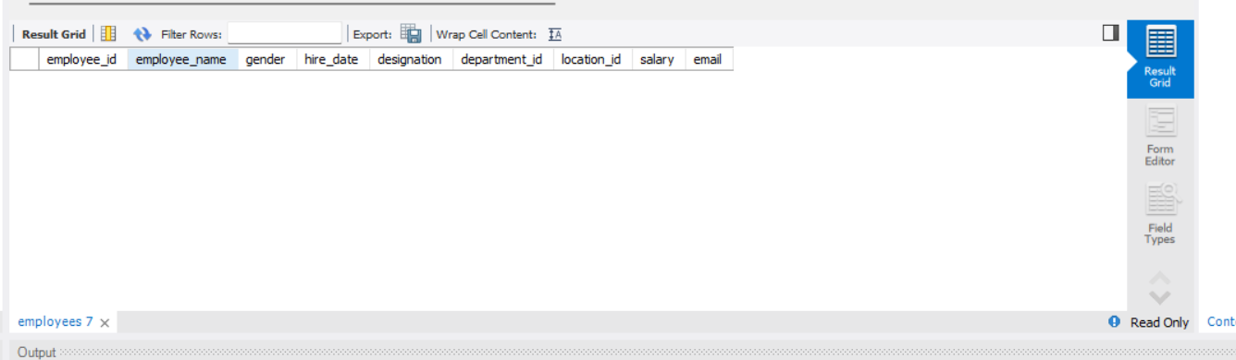

⦿ Rename the “hire_date” column to “date_of_joining”.

Code:

-- rename –

alter table employees
rename column hire_date to date_of_joining;
Output:

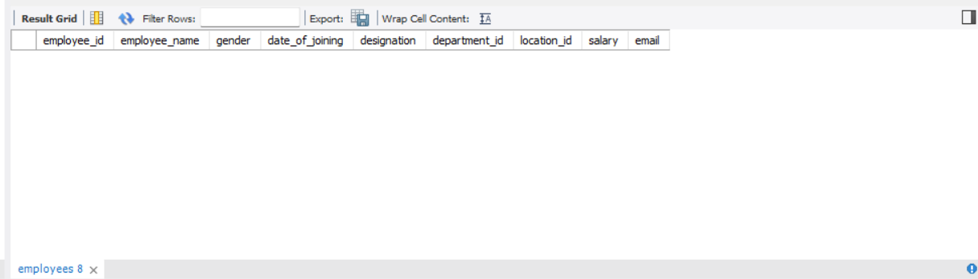

- Table Renaming (RENAME): Rewrite the SQL statements to rename the following tables:

⦿ Rename the "Departments" table to "Departments_Info".

Code:

-- rename --
rename table departments to departments_info;

Output: table name changed
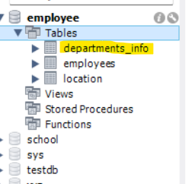
⦿ Rename the "Location" table to "Locations".

Code:

-- rename --
rename table location to locations;

Output: Table name changed
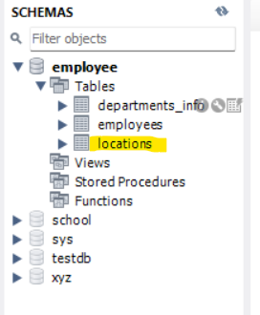

4. Table Truncation (TRUNCATE): Write an SQL statement to truncate the
Employees table.

Code:

-- truncate --
truncate table employees;

Output:
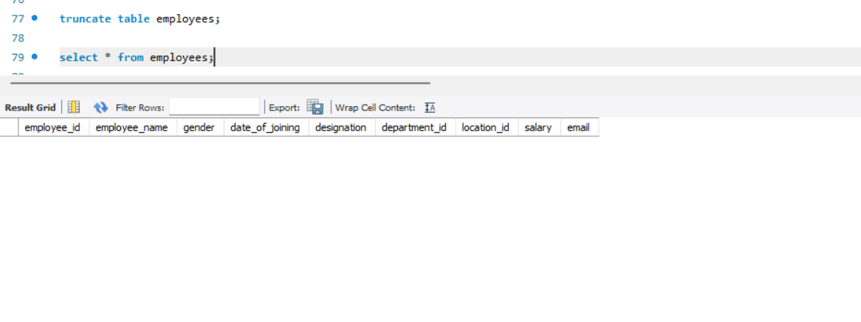

- Database & Table Dropping (DROP): Write the SQL statements to drop the Employees table and then the “employee” database.

Code:

-- drop --
drop table employees;

Output: Table employee removed from the database.

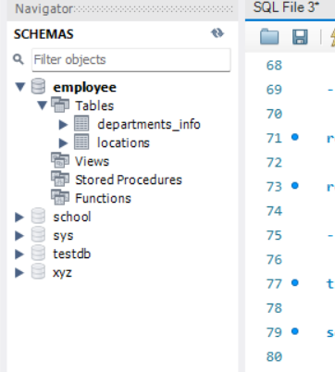

Code:

-- drop database --
drop database employee;

Output:

Database named employee removed from the schemas.
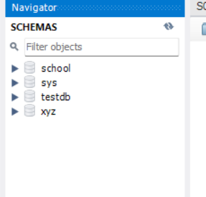

Constraints:

- Database Recreation:

⦿ Drop the 'employee' database if it exists and recreate it using the
provided schema, ensuring that all tables are created with the
appropriate constraints as instructed.

Code:

-- Constraints --
-- drop --

drop database if exists employee;

Output:
Outputs shows Database employee doesn’t exist.

Then we have to create database employee.

Code:
-- create database --

create database employee;
use employee;
Output:

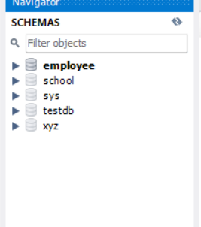

- Departments Table:

⦿ Ensure that the "department_id" uniquely identifies each department.

⦿ Set up constraints on the "department_name" to avoid duplicate and null entries.

Code:
-- create table departments --
create table departments (
department_id int primary key ,
department_name varchar (100) not null unique
);

Output:
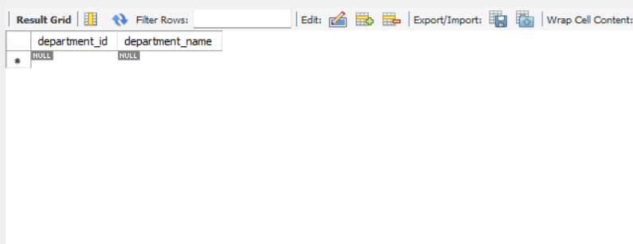

3. Location Table:

⦿ Establish a mechanism to automatically generate unique identifiers for
each location, ensuring that they are incremented sequentially.
⦿ Implement constraints to prevent the insertion of null and duplicate
locations.

Code:
-- create table location --

create table location (
location_id int auto_increment primary key ,
location varchar (100) not null unique );

Output:

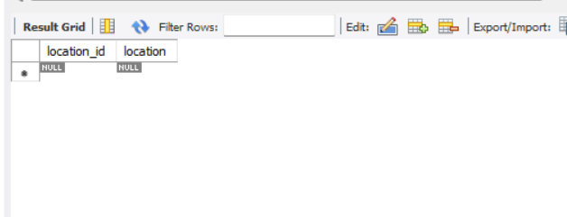

4. Employees Table:

⦿ Guarantee that each employee has a distinct identifier.
⦿ Create a restriction to ensure that the employee's name is always
provided.
⦿ Limit the acceptable values for the "gender" field to only 'M' or 'F'.
⦿ Enforce a condition to ensure that the employee's age is 18 or above.
⦿ Automatically assign the current date to the "hire_date" field if not
specified.
⦿ Establish links between the "department_id" and "location_id" fields in
the "employees" table and their respective tables.

